

**PineconePi Watch**

**Development Report**

Chengsen Dong

G20841536

Electronic Systems Applications

EL2205

Zhijie Ding

12/04/2021

*I confirm that the present assignment is all my own work and the source of any information and material I have used (including the Internet) has been fully identified and properly acknowledged as required in the School guidelines I have received.*

*Signed: Chengsen Dong*

Table of Contents

1. Project Planning 3

1.1 Project Objectives 3

1.2 Division of project personnel 3

1.3 Project Gantt Chart 3

2.Project development 4

2.1 Hardware development 4

2.1.1 Hardware block diagram 4

2.1.2 Component selection 5

2.1.3 Schematic diagram 6

2.1.4 PCB diagram 7

2.1.5 Shell design 11

2.1.6 Whole assembly 13

2.2 Software development 16

2.2.1 Software flow chart 16

2.2.2 STC coprocessor software 16

2.2.3 Web page code 17

2.3 System test 18

2.3.1 Sensor test 18

1.3.2 Hardware test 19

2.3.3 Web server test 19

2.3.4 Overall function test 20

3.Conclusion 21

4. References 22

# Project Planning

## 1.1 Project Objectives

The goal of this project is to develop a wearable portable device. This device should contain some sensors to monitor the most basic biological characteristics (including heart rate, body temperature and exercise). In addition, the device should also have a graphical interface for displaying sensor values. At the same time, the data collected by the equipment should be transmitted to the computer for display in some way.

## Division of project personnel

|  |  |
| --- | --- |
| category | principal |
| Hardware development | Chengsen Dong |
| Software development | Chengsen Dong |
| Equipment test | Chengsen Dong |
| Document writing | Chengsen Dong |

## 1.3 Project Gantt Chart

In order to better manage the progress of the project, I split the project into four parts for implementation. The four parts are hardware development, software development, equipment testing, and document writing. The detailed task schedule and time schedule of each part will be displayed in the form of Gantt chart.

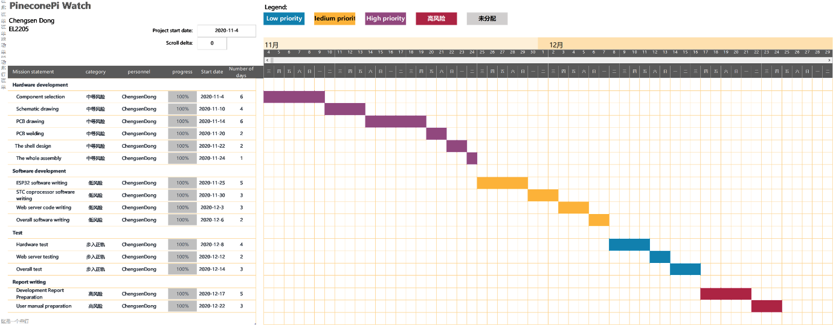

Figure 1 Project Gantt Chart

# Project development

## 2.1 Hardware development

### 2.1.1 Hardware block diagram

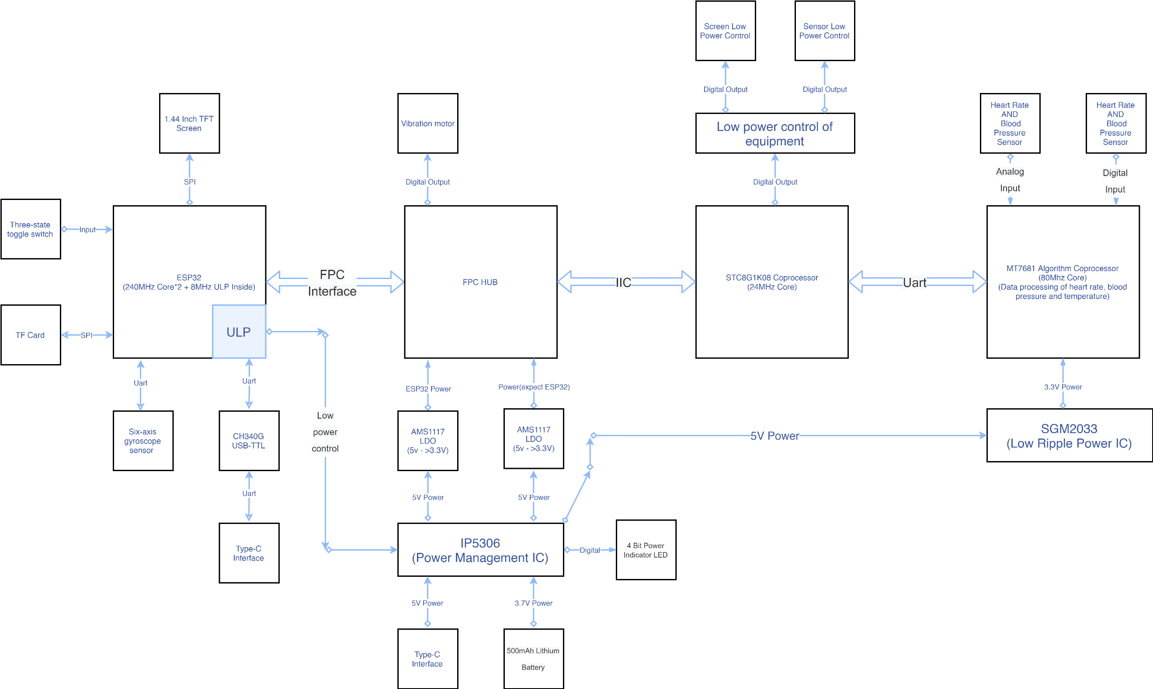

Figure 2 Project hardware block diagram

In order to show the hardware structure of the project more intuitively, the hardware block diagram of the project is shown above. Now the hardware block diagram will be introduced in detail:

1. The hardware of this device is composed of 3 microcontrollers and 5 cores. Among them, ESP32 and STC8 coprocessor are connected through FPC cable. They use the IIC communication protocol for communication and data transmission.

2. The device power is managed by the IP5306 power management chip. IP5306 can automatically select the device power supply provided by the TYPE-C interface or provided by the internal 500mAh lithium battery according to the actual situation. At the same time, the IP5306 power management chip can also charge the lithium battery and indicate the power of the device through a 4-digit LED light.

3. Program download and serial communication with the computer through CH340G USB-TTL chip to convert USB level and TTL level.

4. The 8MHz ULP processor inside ESP32 is mainly used to control the low power consumption function of the device when the device is sleeping.

5. The STC8 coprocessor is mainly used to process the data transmitted by the MT7681 algorithm chip through the serial port, and transmit the data to the ESP32 through the IIC protocol. At the same time, the STC8 coprocessor controls the power supply of the TFT screen of the device and the power supply of the sensor.

6. The user controls the device through the 3-state DIP switch.

7. The MT7681 algorithm chip reads the data of the heart rate and blood pressure sensor and the body temperature sensor, and transmits the data to the STC8 coprocessor through the serial port.

### 2.1.2 Component selection

Now the component selection is listed as follows:

1. Main control chip: ESP32 module (provide 2.4GHz WIFI+Bluetooth)

ESP32 is a series of low-cost, low-power system-on-chip microcontrollers with integrated Wi-Fi and dual-mode Bluetooth functions. The ESP32 series uses Tensilica Xtensa LX6 microprocessors in both dual-core and single-core versions, and includes built-in antenna switches, RF baluns, power amplifiers, low-noise receiving amplifiers, filters and power management modules. ESP32 was created and developed by Espressif Systems, a Chinese company in Shanghai, and manufactured by Taiwan Semiconductor Manufacturing Company (TSMC) using its 40 nm process. It is the successor product of ESP8266 microcontroller. (Wikipedia, 2021)

2. 4-wire SPI display: 1.4-inch ISP LCD screen (resolution: 128*128||Interface: 4-wire SPI||driver chip: ST7735S||14Pin soldering socket)

3. Pulse sensor: YK1801

4. Body temperature sensor: WD3703

5. Algorithm chip: MT7681

6. 6-axis acceleration/angular velocity/angle chip: ICM-42605

ICM-42605 is a 6-axis MotionTracking device that combines a 3-axis gyroscope and a 3-axis accelerometer in a 2.5×3×0.91 mm (14-pin LGA) small package.

ICM-42605 includes on-chip 16-bit ADC, programmable digital filter, embedded temperature sensor and programmable interrupt. The operating voltage range of the device is 1.71V-3.6V. The host interface supports I3C SM protocol up to 12.5MHz (data rate up to 12.5Mbps in SDR mode and 25Mbps data rate in DDR mode), I 2 C protocol up to 1MHz and SPI protocol up to 24MHz. (tdk, 2021)

7. Battery: 500Mah lithium battery

8. 5v->3.3v LDO: AMS1117

9. Power management chip: IP5306

10. Low ripple 5v->3.3v LDO: SGM2033

11. 4-wire SPI SD card slot: storage system picture/WIFI account password/user settings

12. 4-pin toggle switch (3 states)

13. Tip: Vibrate the motor

14. TYPE-C interface (charging and communication/upgrade firmware)

### 2.1.3 Schematic diagram

The schematic diagram is mainly composed of the top PCB schematic diagram and the bottom PCB schematic diagram:

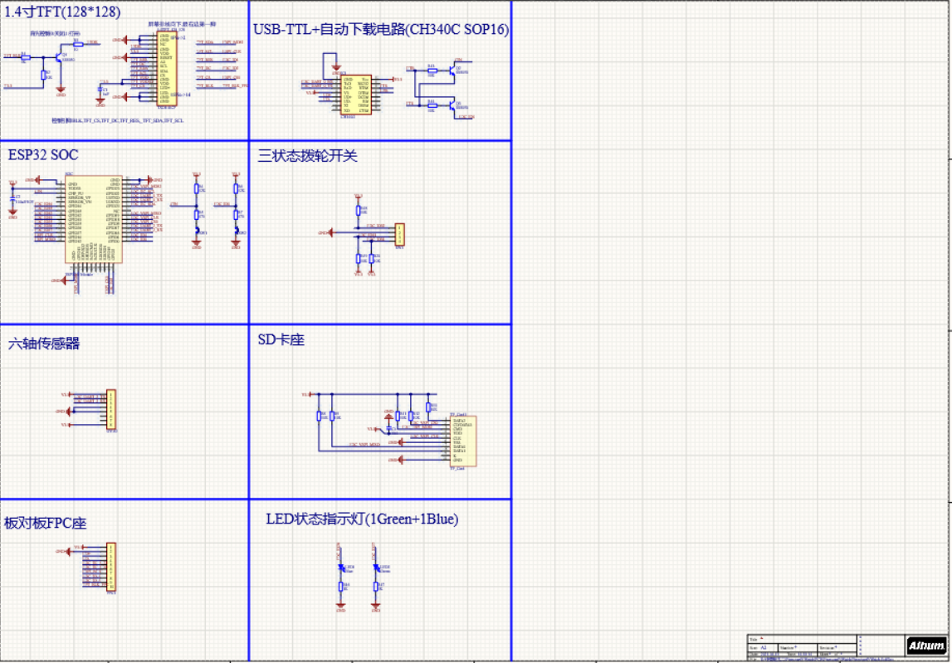

Figure 3 Schematic diagram of the top PCB

The PCB schematic diagram at the top includes the schematic diagram of ESP32, CH340G, 1.44 inch TFT screen, TF card holder, ICM 6-axis gyroscope sensor, and 3-state DIP switch.

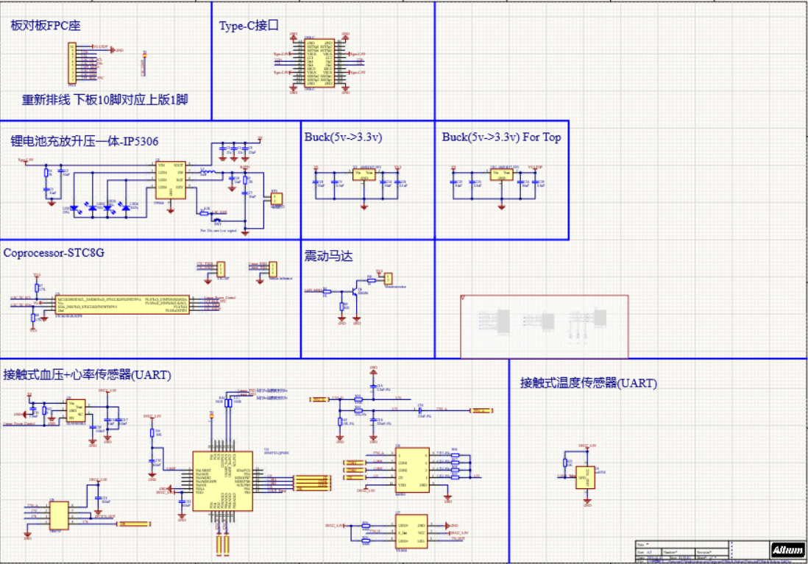

Figure 4 PCB schematic diagram at the bottom

The PCB schematic diagram at the bottom includes TYPE-C interface, IP5306 power management chip, STC8 coprocessor, MT7681 algorithm chip, heart rate and blood pressure sensor, body temperature sensor, vibration motor, and the schematic diagram of 5v->3.3vLDO.

### 2.1.4 PCB diagram

The PCB drawing of this equipment follows the following rules:

1. The signal line is routed at 6 mils, and the power line is routed at 10 mils.

2. There is no right-angle wiring during the wiring process, and the wiring is at a 45° acute angle.

3. Pour copper on both sides of the PCB and remove the dead copper. Improve the anti-interference ability of the equipment.

4. The filter capacitor is placed close to the power supply pin of the chip.

5. Reasonably lay out the heating elements to prevent the heat from being concentrated on one part of the PCB and affecting the circuit performance.

The following will show the top PCB, bottom PCB wiring diagram and 3D simulation diagram in turn:

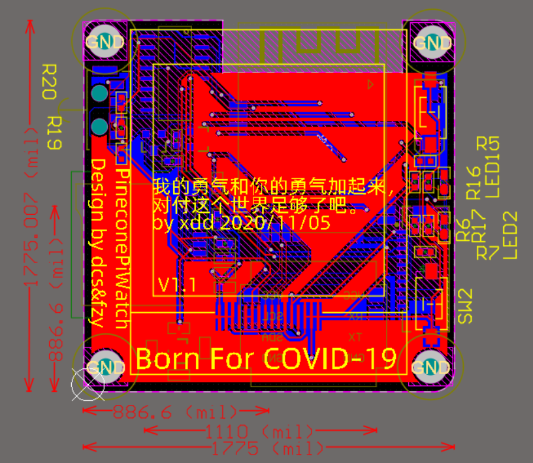

Figure 5 Top PCB wiring diagram

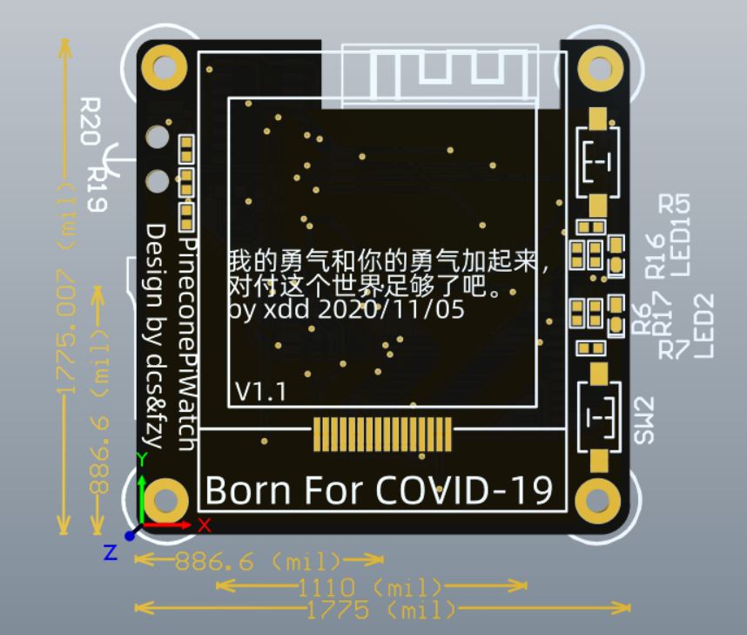

Figure 6 3D simulation of the top PCB 1

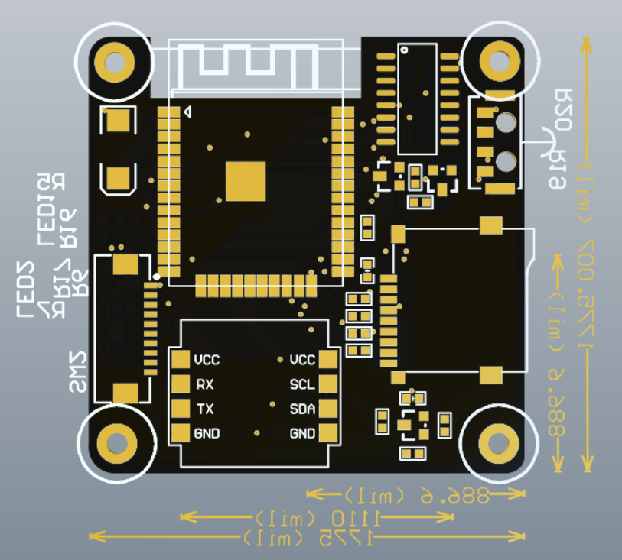

Figure 7 3D simulation of the top PCB 2

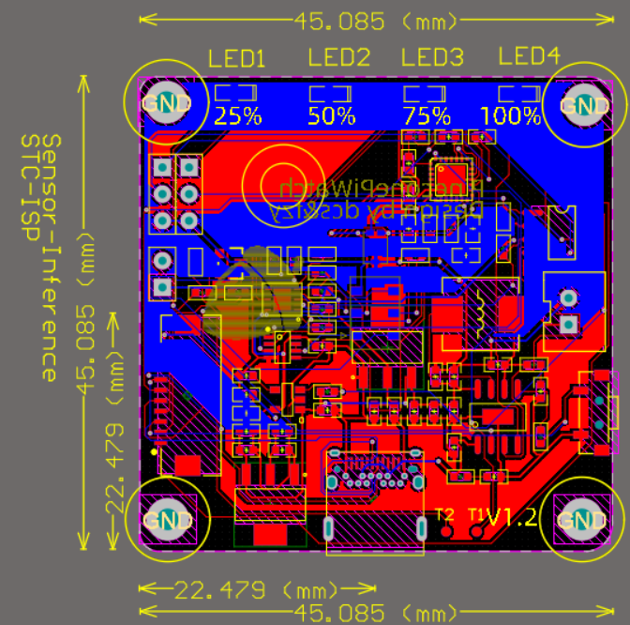

Figure 8 Bottom PCB wiring diagram

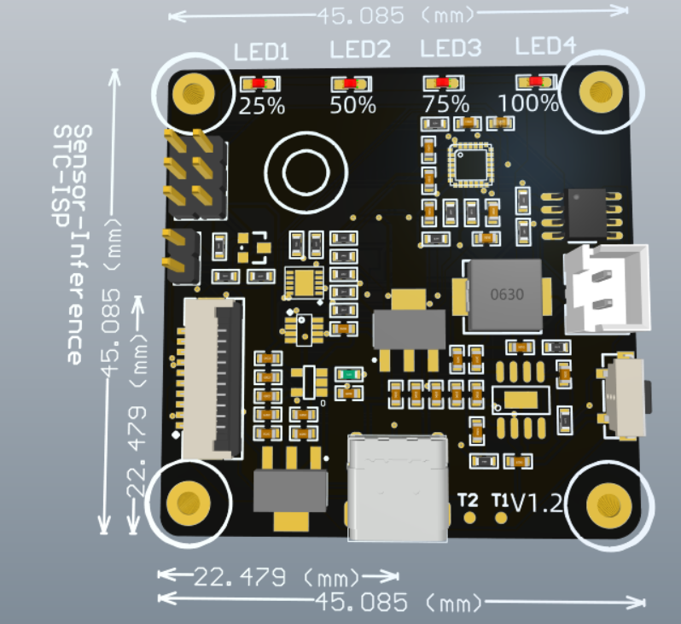

Figure 9 Bottom PCB 3D simulation diagram 1

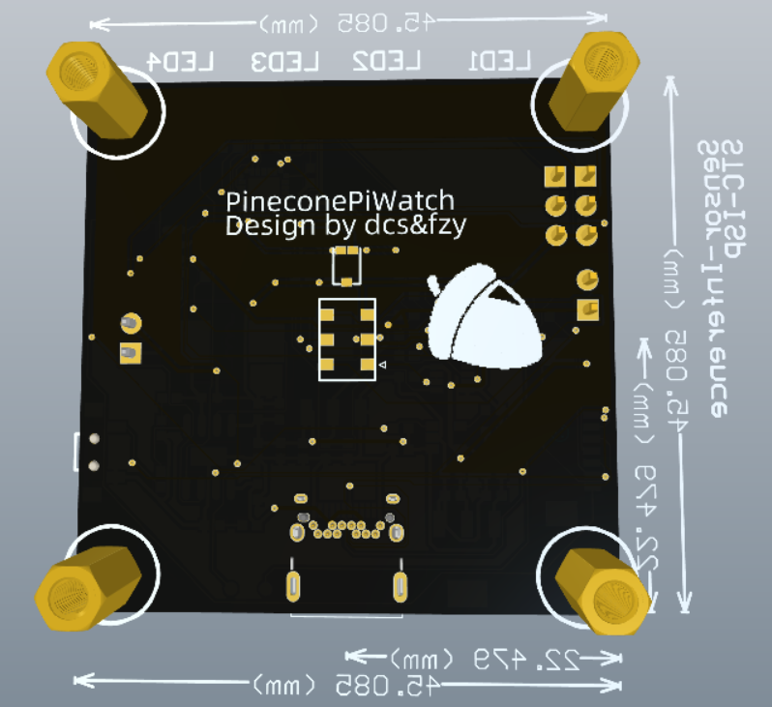

Figure 10 Bottom PCB 3D simulation diagram 2

、

### 2.1.5 Shell design

The shell is designed using Fusion 360 software, and the .STL file is output after the design is completed. Finally, it is printed by a photosensitive 3D printer.

First import the 3D model of the PCB into the Fusion 360 design software.

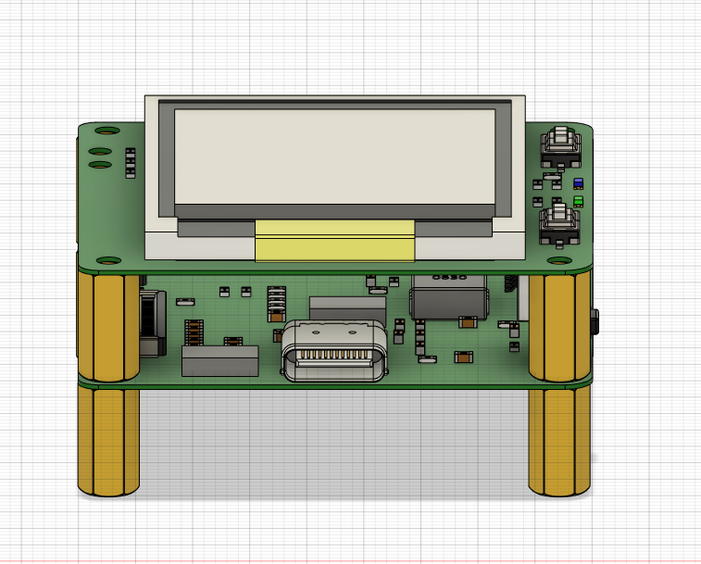

Figure 11 PCB 3D simulation diagram 1

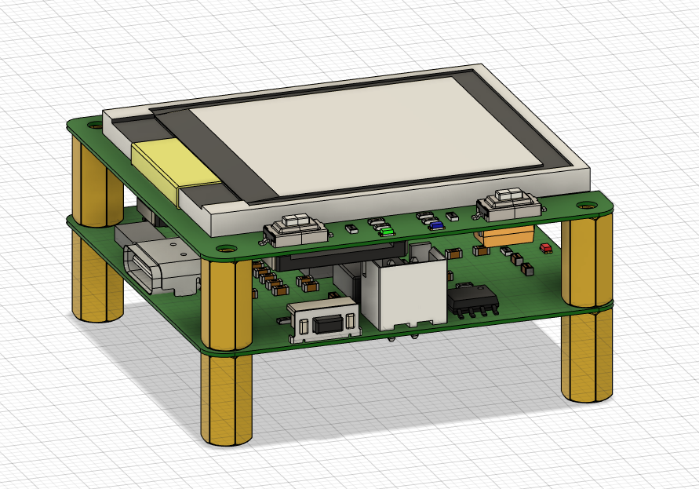

Figure 12 PCB 3D simulation diagram 2

Then draw out the shell entity according to the PCB3D simulation diagram, and reserve screw holes. (The simulation shows that there is interference between the four copper pillars under the shell and the shell body, but it does not exist in reality and can be ignored)

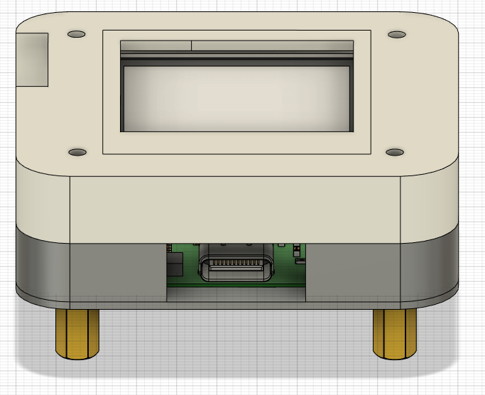

Figure 13 Overall simulation 1

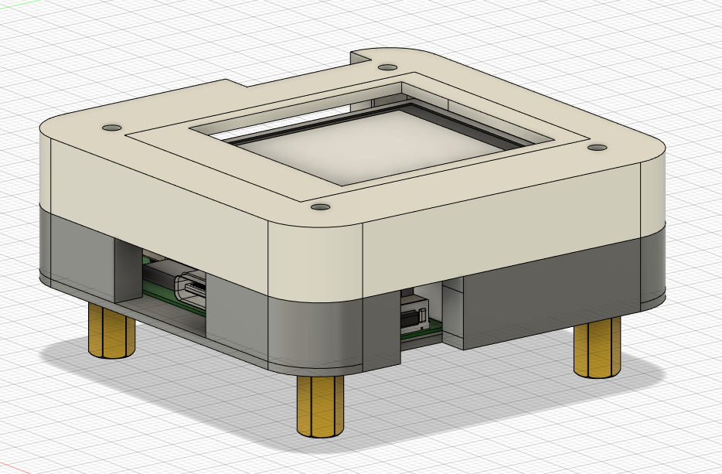

Figure 14 Overall simulation 2

Finally, the PCB3D entity is removed, and finally a device enclosure that meets the physical size of the PCB is obtained.

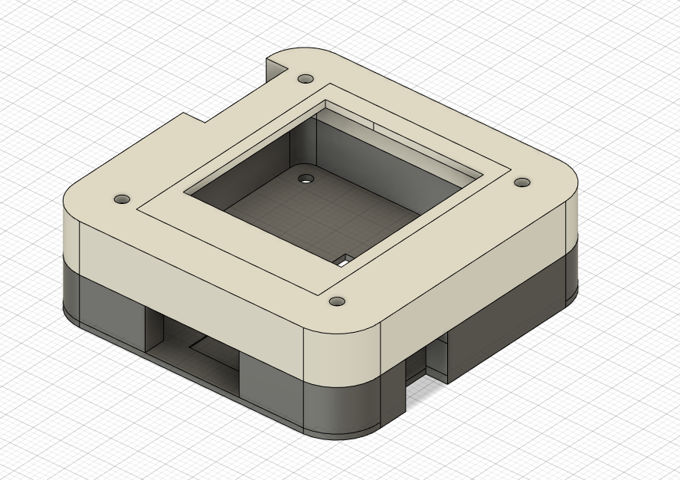

Figure 15 Equipment shell

### 2.1.6 Whole assembly

Because the internal PCB of this device uses the capacitor resistor of 0603 package, and some chips are relatively small. In order to improve the welding success rate, a welding auxiliary steel mesh is customized.

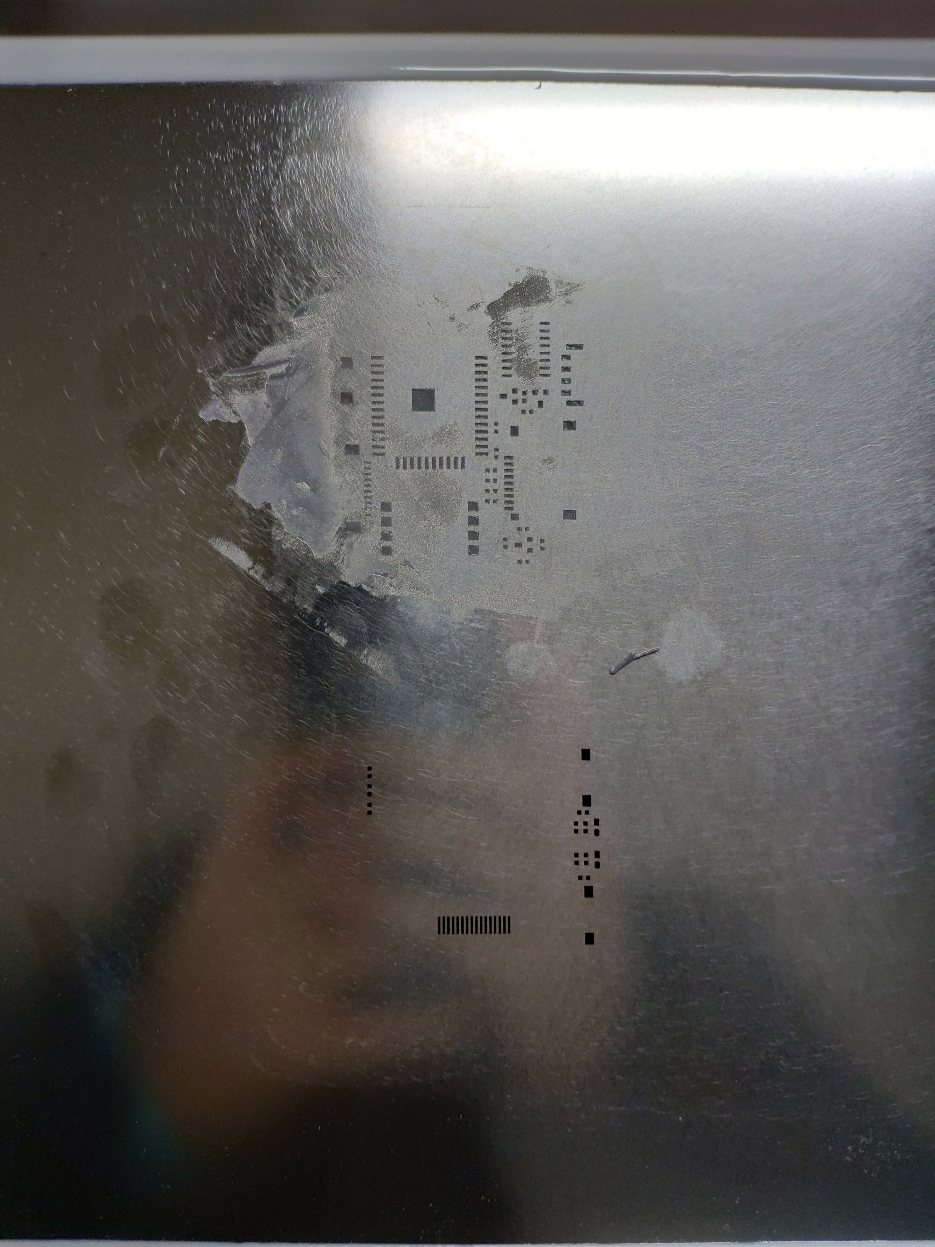

Figure 16 Welding auxiliary steel mesh

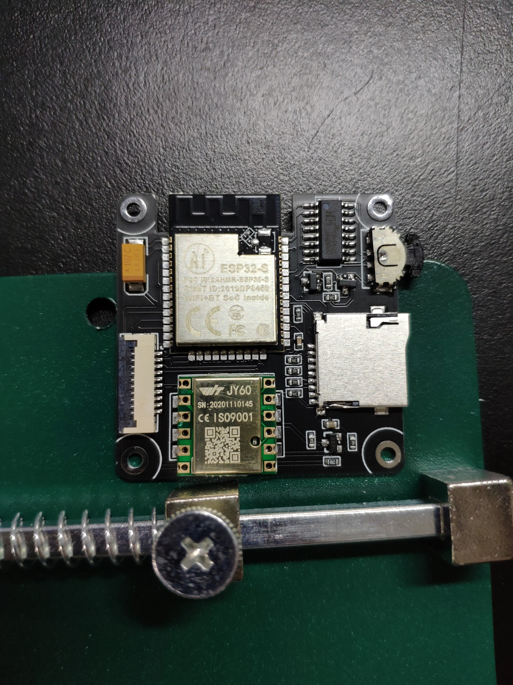

Figure 17 Top PCB soldering

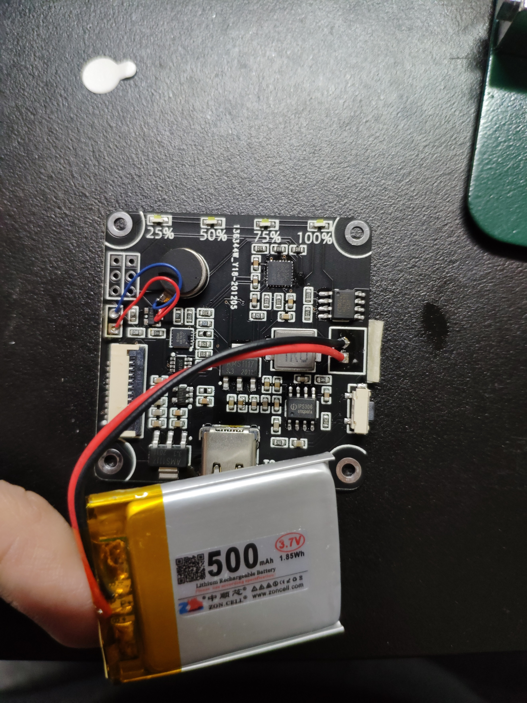

Figure 18 PCB soldering on the bottom

Finally, connect the bottom PCB and the top PCB through the FPC cable. Put the two into the photosensitive resin case and tighten the screws. Finally complete the overall assembly.

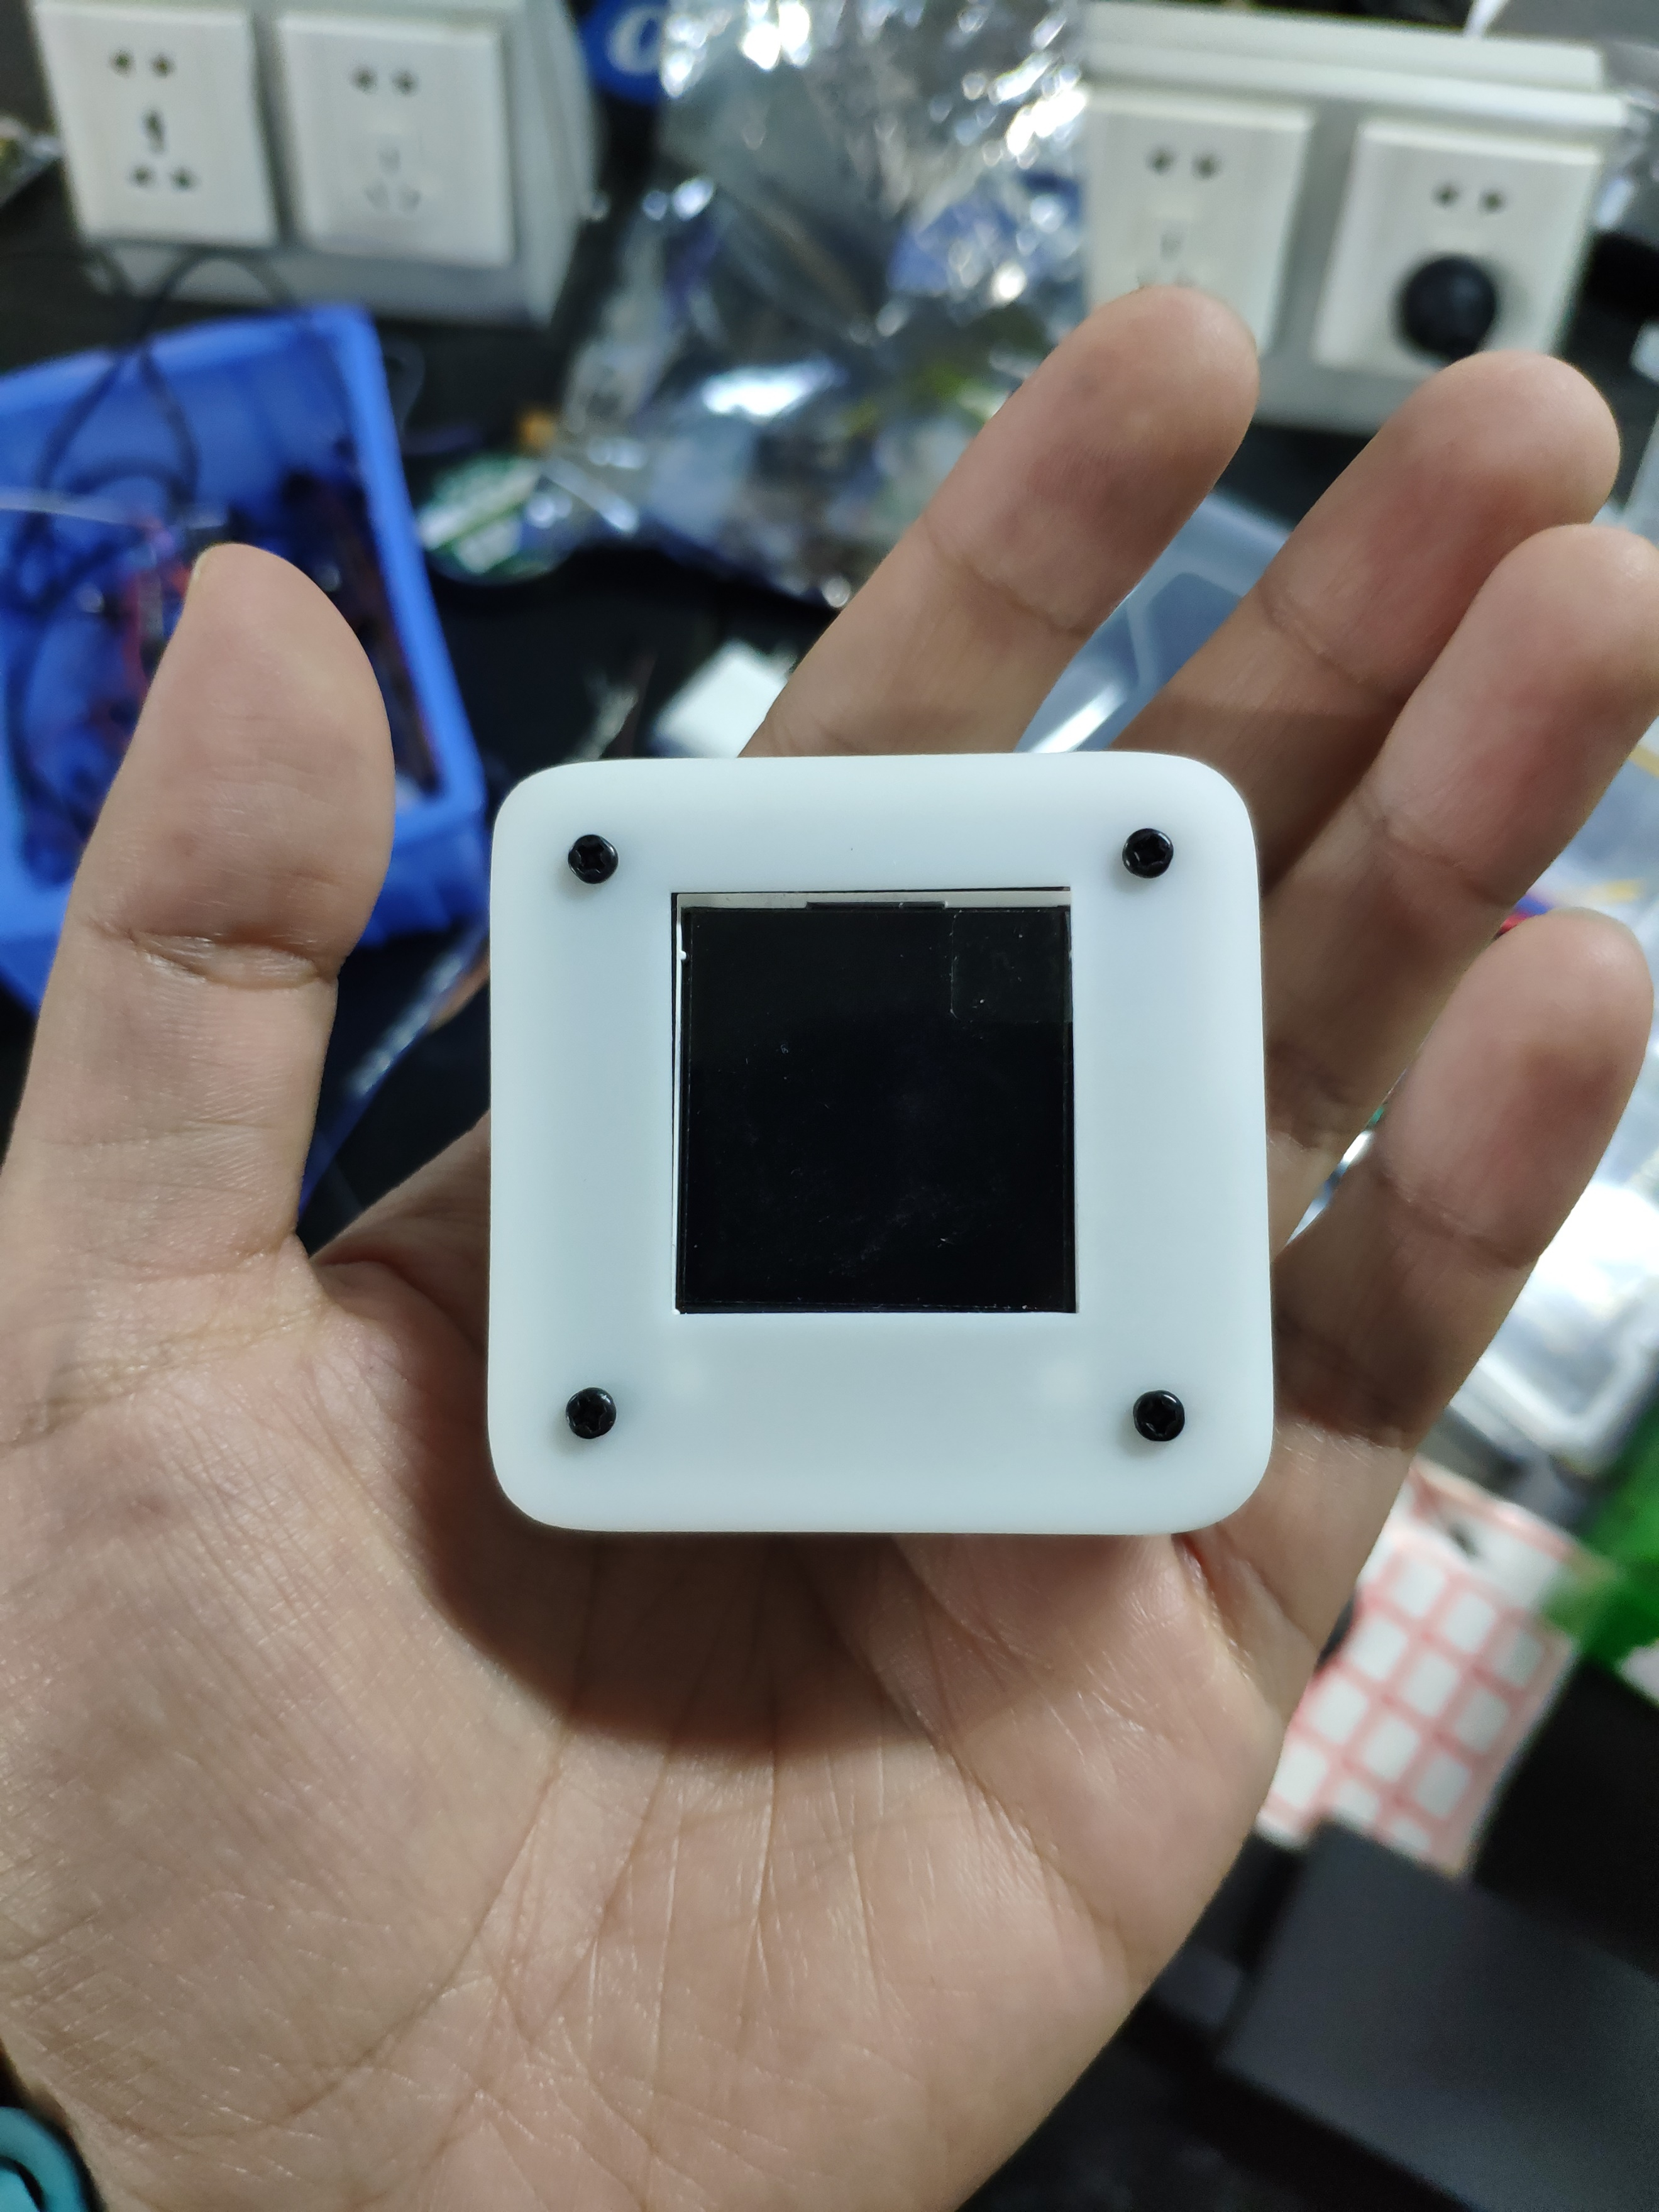

Figure 19 Overall assembly

## 2.2 Software development

### 2.2.1 Software flow chart

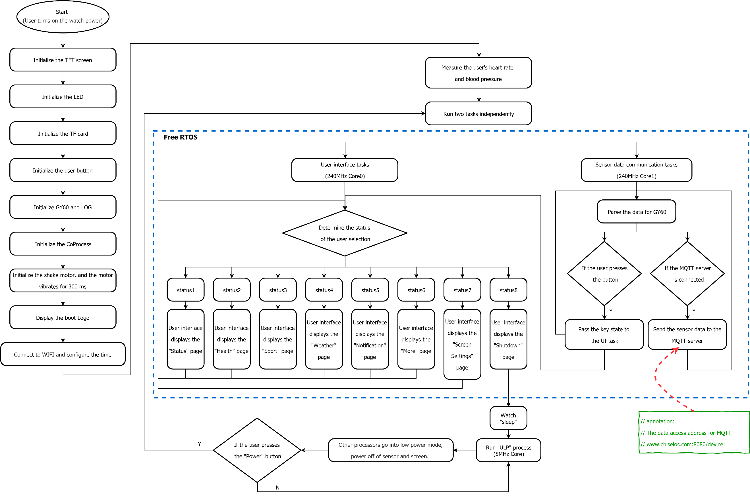

Figure 20 Software flow chart

The above is the software flow chart of this device. After the user presses the power button, start to initialize the screen, TF card, 6-axis gyroscope and other sensors, and check whether the sensor is online. Finally, Free RTOS is used to schedule the two processor cores of ESP32. The processor core 0 runs the TFT screen display task. The processor core 1 runs sensor data processing tasks and WIFI communication tasks. When the sleep button is pressed, all cores except the 8Mhz ULP core will enter sleep mode. The power of the sensor and the TFT screen will be turned off. Under this measure, the power consumption of the device will be reduced to a minimum.

### 2.2.2 STC coprocessor software

This chapter will focus on the software part of the STC coprocessor. The STC coprocessor mainly has the following functions in this device:

1. Due to the insufficient number of ESP32 pins, it cannot drive enough peripherals. Therefore, the ESP32 master sacrifices 2 pins as IIC to drive more peripheral devices.

2. Control the power supply of the screen and the sensor in order to realize the low power consumption management function.

3. Receive heart rate, blood pressure and body temperature data sent by the MT7681 algorithm chip through the serial port.

Use Keil to write the STC8 coprocessor program as follows:

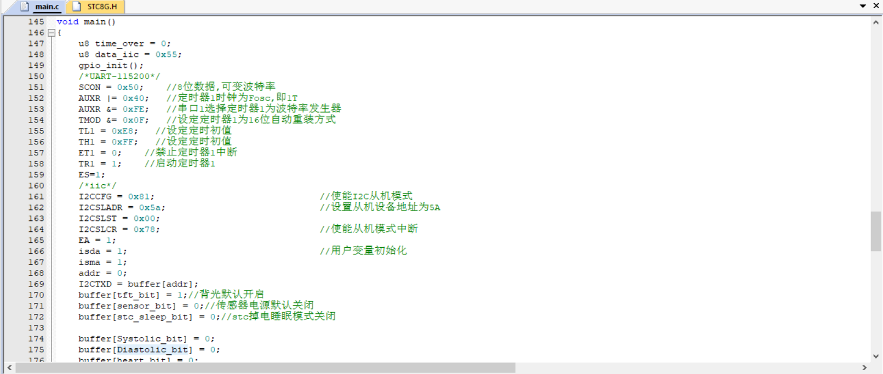

Figure 21 STC8 code screenshot

### 2.2.3 Web page code

This device uses Django under the Python language to develop web pages. Django is an open source web application framework, written in Python. The framework pattern of MVC is adopted, namely Model M, View V and Controller C. It was originally developed to manage some news content-based websites under the Lawrence Publishing Group, which is CMS (Content Management System) software. It was released under the BSD license in July 2005. This frame is named after Belgian gypsy jazz guitarist Django Reinhardt. Django is a framework based on MVC construction. But in Django, the part of the controller that accepts user input is handled by the framework itself, so Django is more concerned with the model (Model), template (Template) and view (Views), called MTV mode. Django is suitable for rapid web development.

In the web page code, the following functions are mainly implemented:

1. Connect to the MQTT server, subscribe to the corresponding topic, monitor the data sent by the device and dynamically display it on the Web page.

2. Whenever the web page is refreshed, send a query command to the device via MQTT.

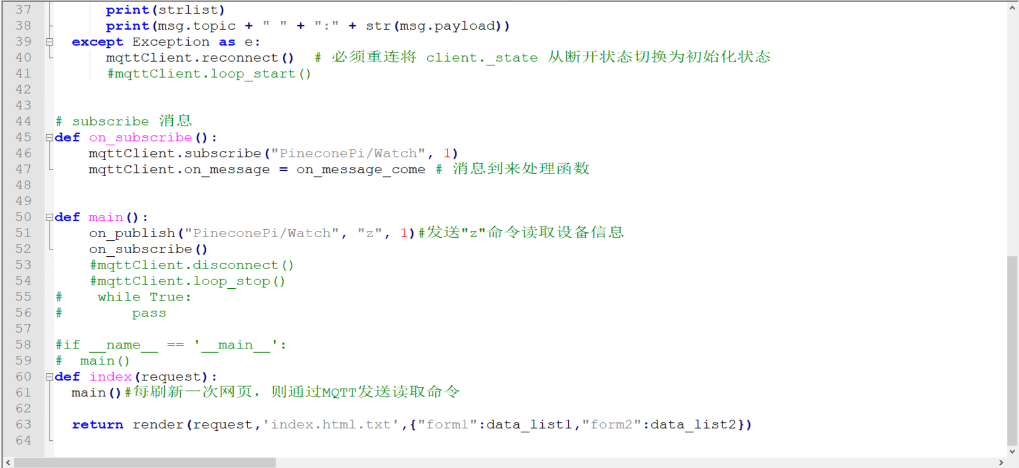

Figure 22 Django Web code

## 2.3 System test

### 2.3.1 Sensor test

Test the heart rate, blood pressure, and temperature data output by the MT7681 algorithm chip as follows:

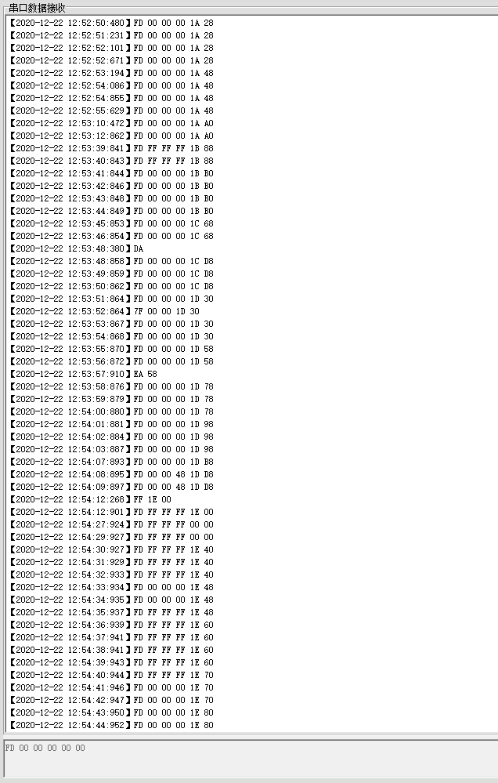

Figure 23 MT7681 algorithm chip data return

### Hardware test

The equipment hardware test ensures that the sensors work normally, the screen works normally, and the charge and discharge functions are normal. The effect is as follows:

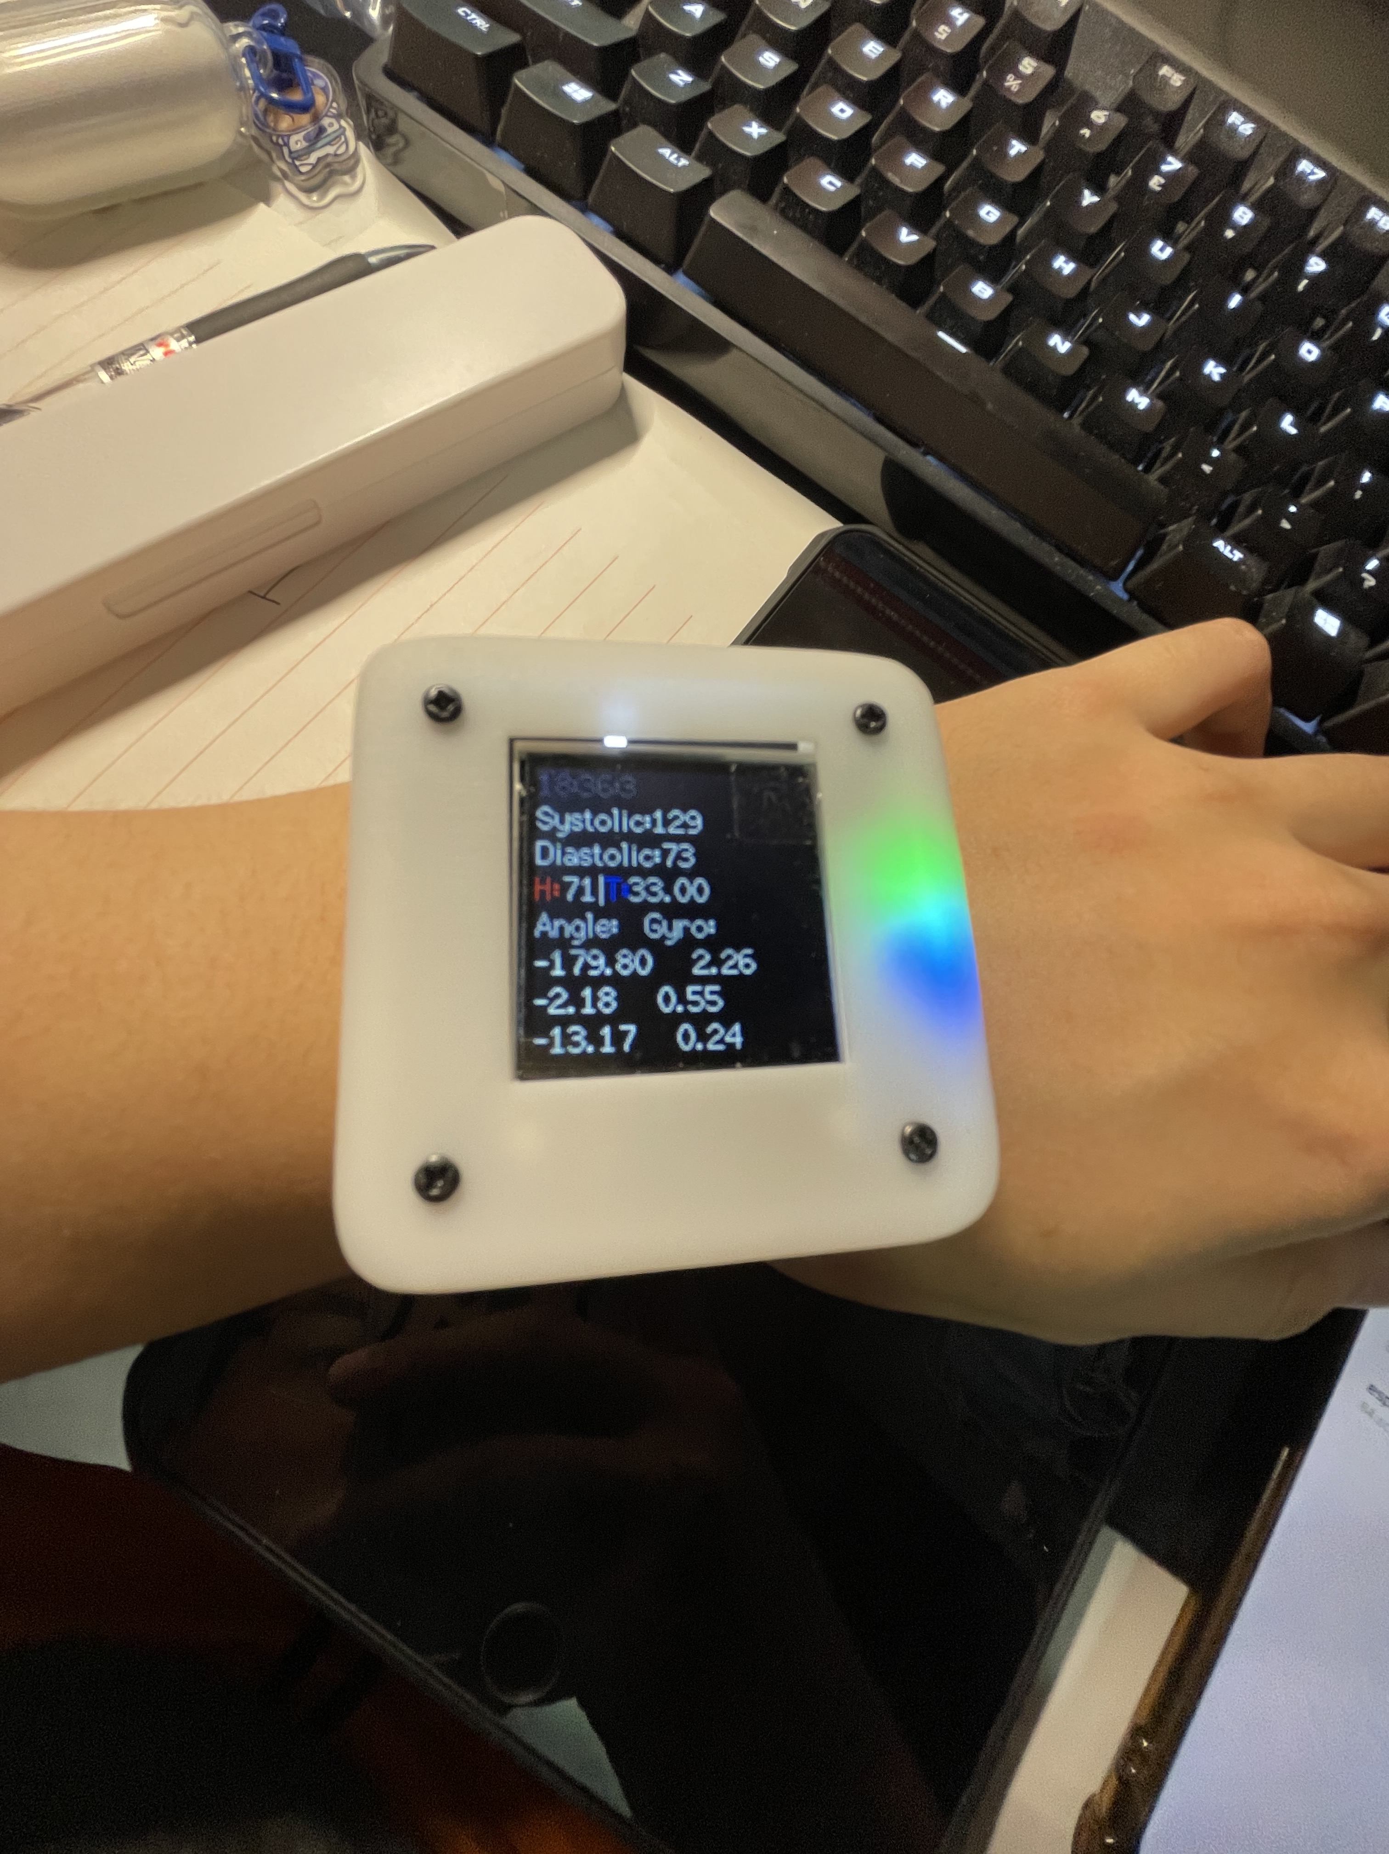

Figure 24 The device hardware test success diagram

### 2.3.3 Web server test

The web server test ensures that Django runs normally and can receive MQTT server messages normally. The test results are as follows:

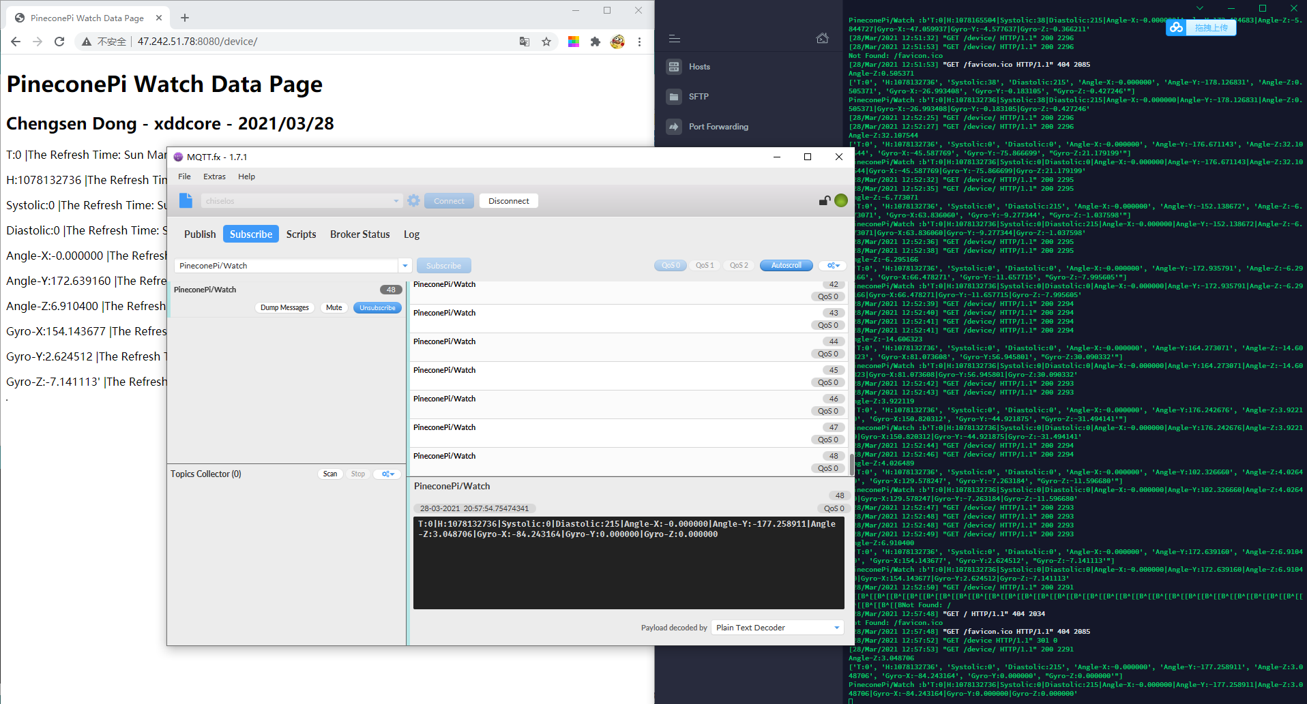

Figure 25 Web server test success diagram

### 2.3.4 Overall function test

In the overall test, it should be ensured that the watch is running normally and the MQTT server is running normally. As shown below:

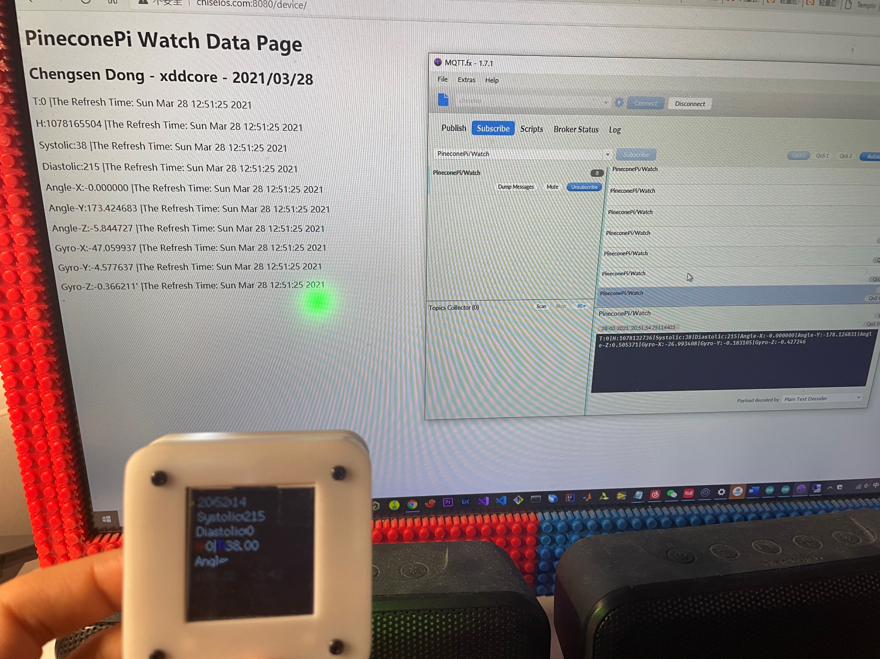

Figure 25 Overall test success diagram

# 3.Conclusion

In this project development report, the formulation of project objectives, project task planning, and project task Gantt chart design have been completed. It also demonstrated the development and design process of the project's software and hardware. Finally, the test process of the project was shown, which proved that the project successfully met the expected requirements and the design was successful.

# 4. References

Wikipedia, W., 2021. ESP32 - Wikipedia. [online] En.wikipedia.org. Available at: <https://en.wikipedia.org/wiki/ESP32> [Accessed 14 April 2021].

tdk, t., 2021. *ICM-42605 | TDK*. [online] Invensense.tdk.com. Available at: <https://invensense.tdk.com/products/motion-tracking/6-axis/icm-42605/> [Accessed 14 April 2021].